Course Methods Year 12 test two 2022

Student name: ________________ Teacher name: ________________

Task type: Response

Time allowed for this task: _____40______ mins

Number of questions: ____7_______

Materials required: Upto 3 calculators/classpads allowed

Standard items: Pens (blue/black preferred), pencils (including coloured), sharpener, correction fluid/tape, eraser, ruler, highlighters

Special items: Drawing instruments, templates, one page of A4 notes doublesided

Marks available: ___40___ marks

Task weighting: _10___%

Formula sheet provided: Yes

Note: All part questions worth more than 2 marks require working to obtain full marks.

Q1 (2 & 2 = 4 marks) (3.2.1)
Let ,
- Determine an expression for the rate of change of .
Solution
Specific behaviours
P recognises that derivative is needed
P correct expression

- Determine given that .

Solution
Specific behaviours
P anti differentiates and uses a constant c
P solves for constant

Q2 (3 marks) (3.2.3-3.2.9)
Determine in terms of given that and when .

Solution
Specific behaviours
P anti- diffs and uses plus c
P sets up equation to solve for c
P solves for c (accept approx.)

Q3 (4 marks) (3.2.21-3.2.22)
A particle travels along a straight line such that its acceleration at time seconds is equal to . When the displacement is 10 metres and when the displacement is 20 metres. Determine the displacement when .

Solution
Specific behaviours
P anti diff to find v with constant stated
P anti diff to find x with a new constant
P solves for both constants
P displacement for t=3

Q4 (6 marks) (3.2.19-3.2.20)
Make a sketch showing the graphs of and indicating clearly on your sketch the coordinates (2 dp) of any stationary points, inflection (if any) and of any points where the functions intersect each other.
Determine the area between the graphs to 2 dp.

Solution
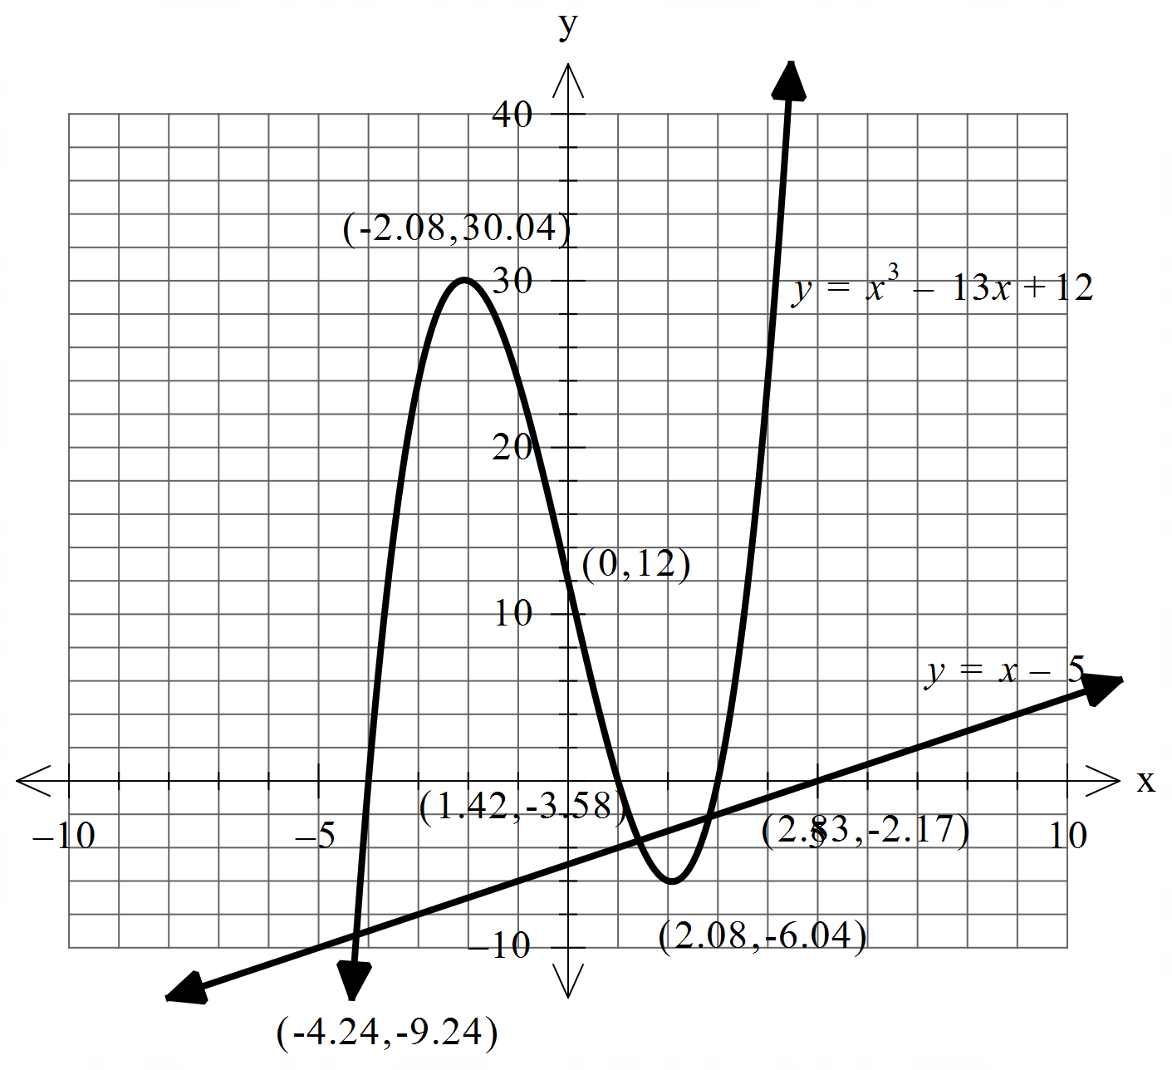

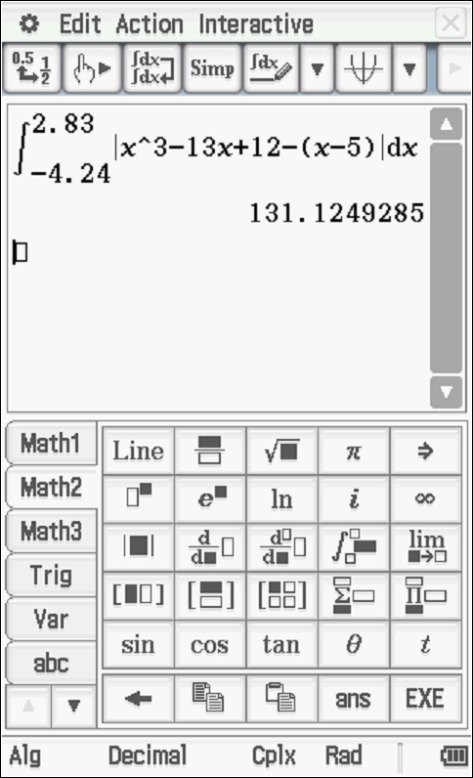
Area = 131.12 sq units (accept 131.13)
Specific behaviours
P states coordinates on sketch for both turning points
P states coordinates on sketch of inflection point
P shows line meeting cubic at 3 points
P states coordinates on sketch of all pts of intersection
P states integral(s) to calculate area between functions
Pstates area to 2 dp
(Note: max -1 if not 2 dp)
(Note: -2 if coordinates not given on sketch but stated elsewhere)

Q5 (4 & 3 = 7 marks) (3.1.2-3.1.3)
Let
- Using calculus determine all stationary points and their nature.

Solution
Specific behaviours
P uses product rule to obtain first derivative
P equates derivative to zero and solves for two values
P uses first or second derivative test to determine nature with actual, values stated(accept approx)
P gives coordinates and nature of each stationary point(accept approx)

- Determine the values of any inflection points.

Solution
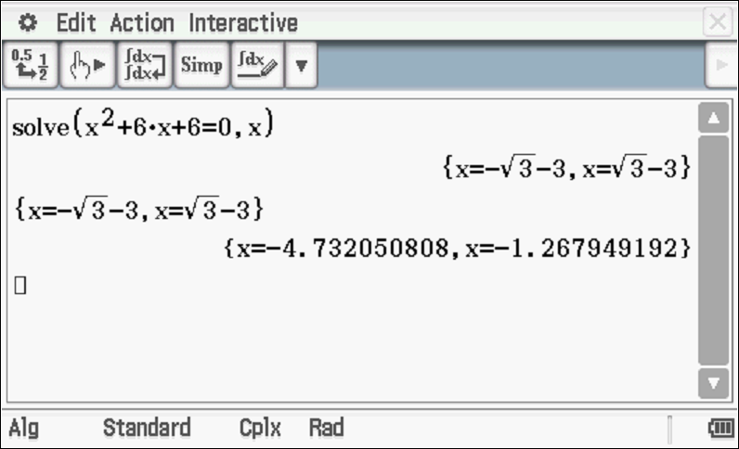
And x=0
Specific behaviours
P shows second derivative equated to zero
P states at least two x values, accept approx
P states three x values, approx.

Q6 (2, 2, 2 & 2 = 8 marks) (3.2.15-3.2.17)
Consider the function which is graphed below.
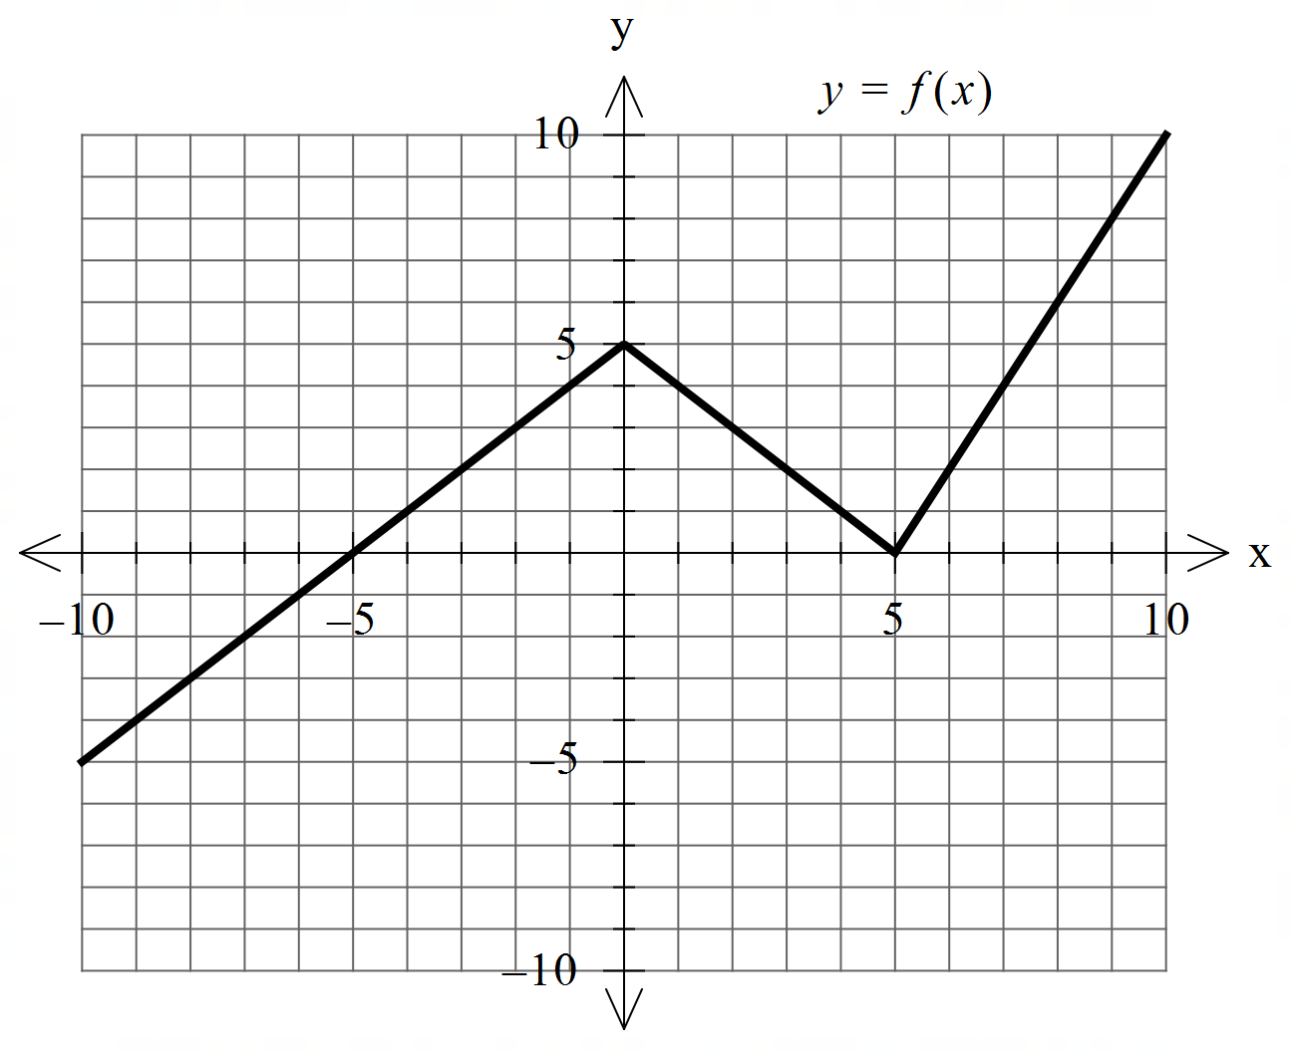

Determine the following.
- .

Solution
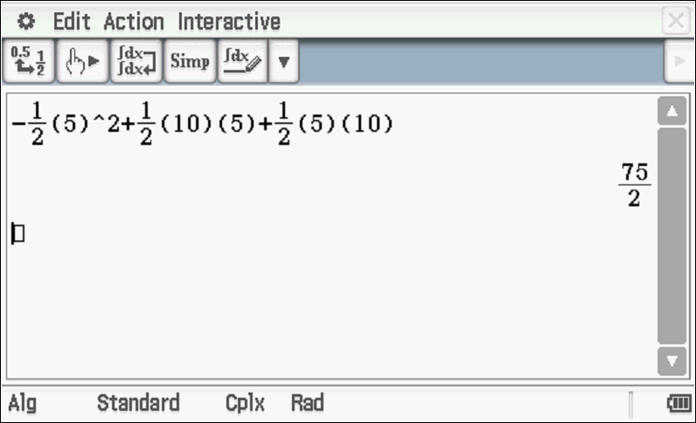

Specific behaviours
P identifies negative result
P states total value

- .

Solution
Specific behaviours
P uses FTC
P states result

- when .

Solution
Specific behaviours
P uses FTC
P states result

- The area enclosed between and the line .

Solution
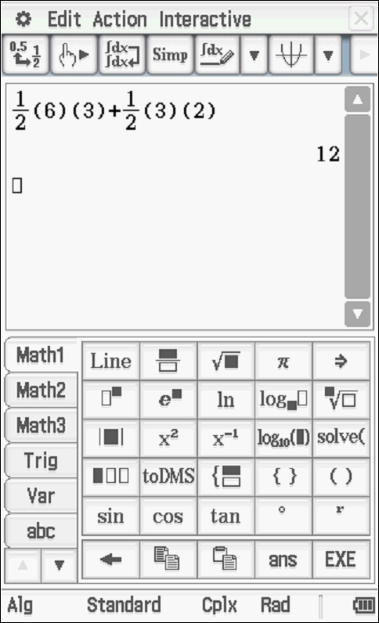

Specific behaviours
P uses two triangles
P states result
(If 4 triangles used giving 52.5 then 1 mark out of 2)

Q7 (1, 3x= & 4 = 8 marks) (3.2.5-3.1.6)
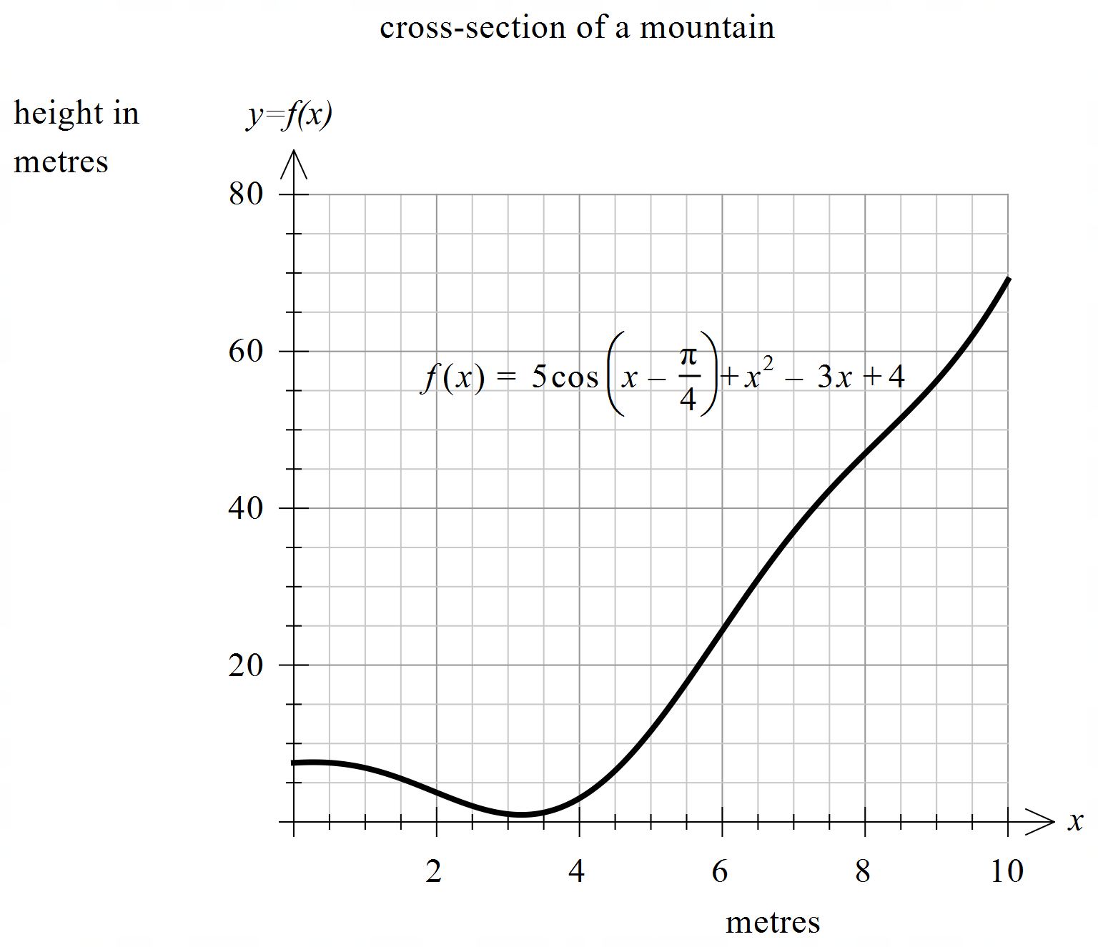The cross section of a mountain can be given by for metres where = height at metres.

- Determine .

Solution
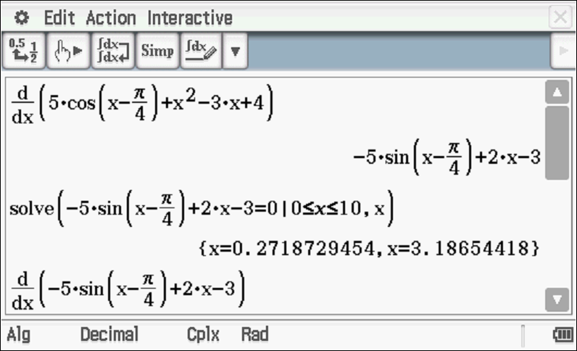

Specific behaviours
P states derivative

- Determine the minimum height of the mountain to 2 decimal places. Justify.

Solution
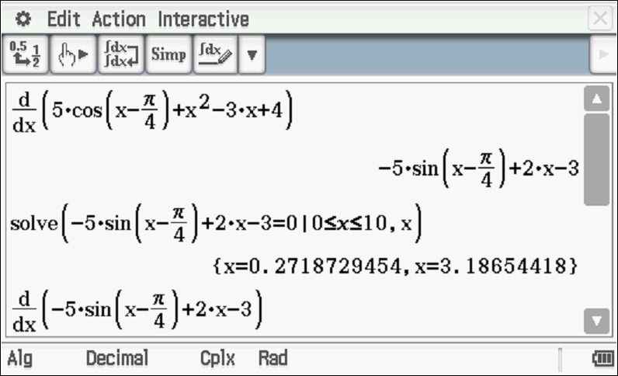
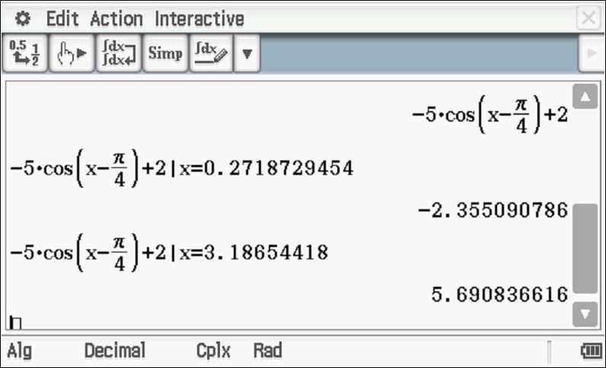
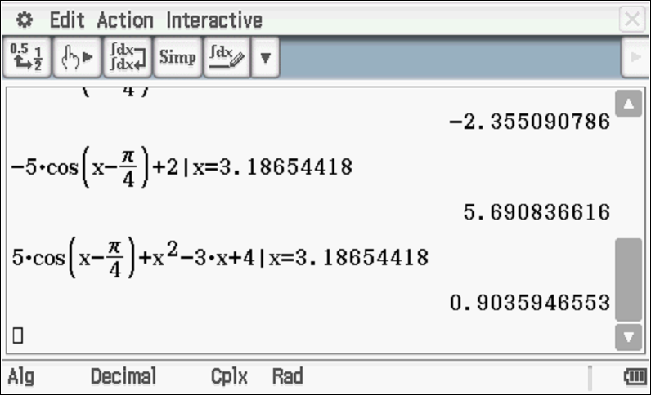
Specific behaviours
P differentiates and equates to zero.
P solves for two x values in domain
P uses first or second derivative test to select local min with y value stated to 2 dp
(no need for units)

- A water collection tank will be placed at the steepest part of the mountain. Determine the coordinates of this point to 2 decimal places. Justify.
Solution
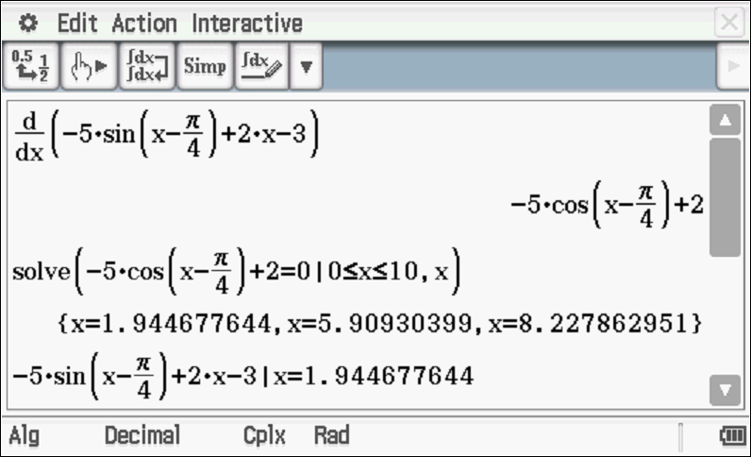
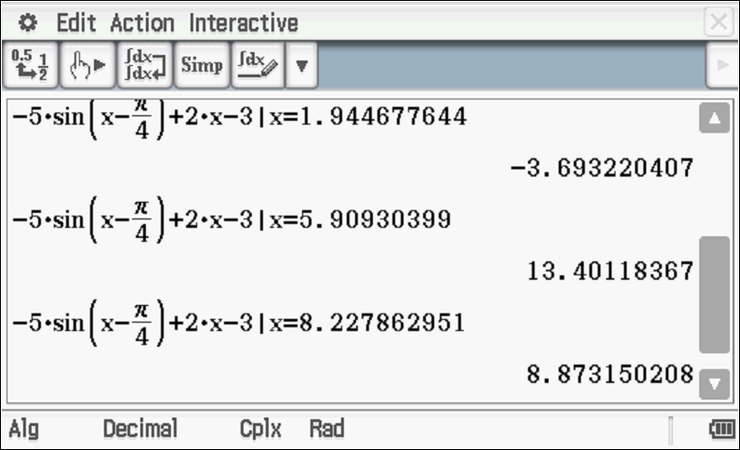
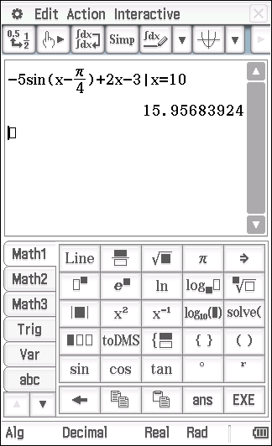
Steepest point is at x=5.91 metres & y = 23.20 metres or 23.19(do not accept 23.2)

Note: accept the endpoint if derivative is given although the endpoints were not supposed to be examined. endpoint of x = 10 metres & y = 69.11 metres
Behaviours unchanged
Specific behaviours
P equates second derivative to zero.
P solves for 3 values of x
P states value of first derivative for at least 2 x values above.
P selects steepest point with x & y values rounded to 2 dp (2 possible answers)
Note : max -1 if 2 dp not used in entire question (no need for units)

Continue with Q7

Extra working space

